

iLoan User Manual

Logging In
In order to use iLoan you must have been assigned a user name , password and appropriate privileges.
Start the program by select it from your Start Menu.
You will then be presented with a login screen similar to the one below.

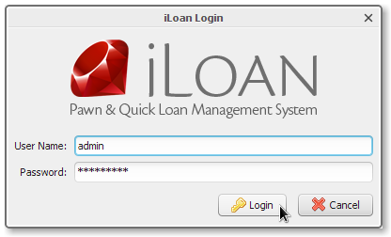
At this point you can enter the user name and password that was assigned to you by your system administrator. Click login and if the credentials were entered correctly you will be presented with the main window.
You can now proceed with your assigned functions.

Adding Customers
To add customers to iLoan select Customers > Add Customer from the main menu to access the Add Customer Screen.
The screen shot below shows where the menu option can be found.
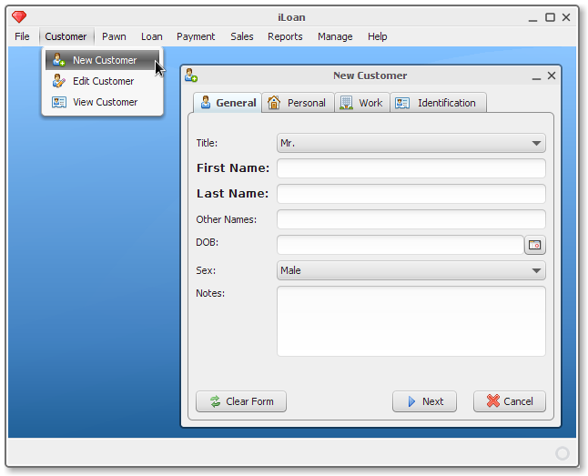
Once the screen has loaded you may proceed to enter the appropriate data.
The following fields are required and you cannot save if this information has not been entered:
- First Name
- Last Name
- DOB

